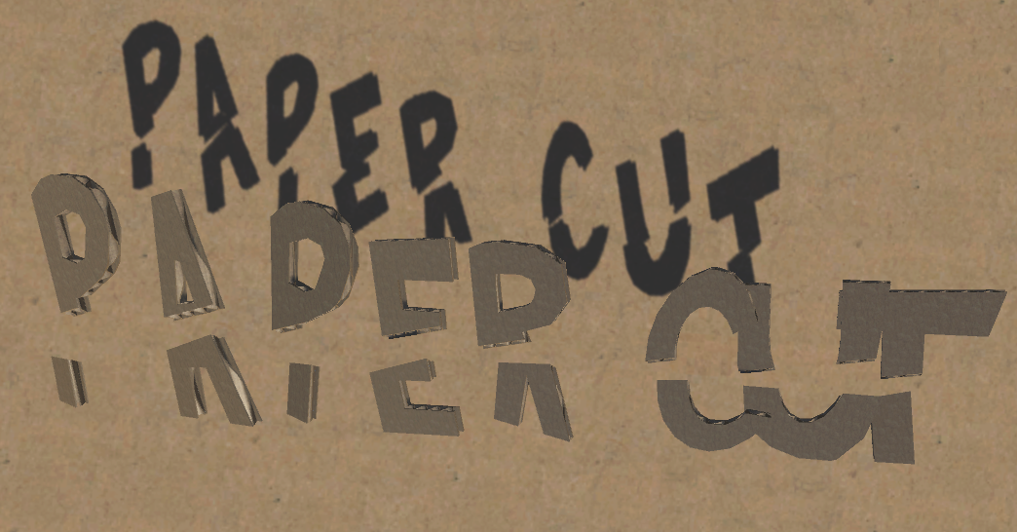  
by

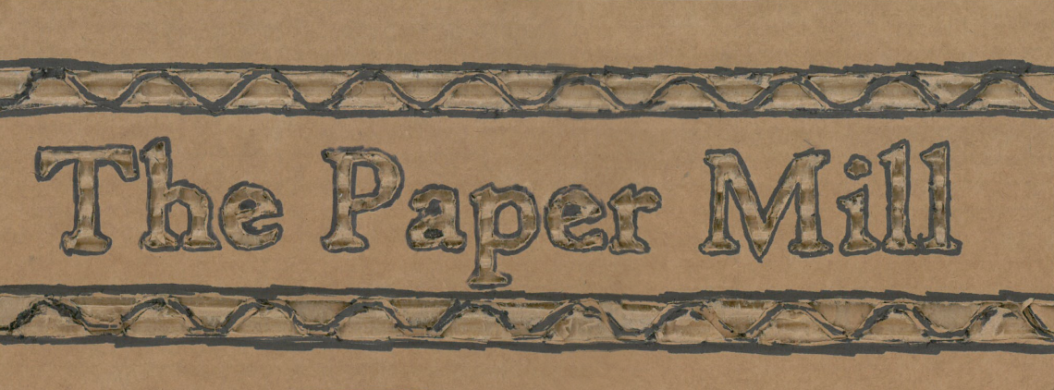

Technical Design Document

TABLE OF CONTENTS

Table of Contents 1

Technical Overview 2

Coding Methods 3

Editor Overview 4

Special Systems 5

Art Pipeline 6

Source Control 7

# Technical Overview

**Additional Tools**



**Visual Studio**

**Engine**



**Unity Engine: Version 5.2**

**Source Control**



**Git Hub**

**Art Tools**



**Maya 2015**



**Photoshop**

**Major Systems**

* **Action System**
* **Interactable System**
* **Conversation System**
* **Input Manger**
* **Mesh Combination**
* **Pull Tabs**
* **Bend Panels**

# Coding Methods

**Team Header File**

Place the following header at the top of each script

/****************************************************************************/

/*!

\file filename.cs

\author Your Name

\brief

Description of script

© 2015 DigiPen, All Rights Reserved.

*/

/****************************************************************************/

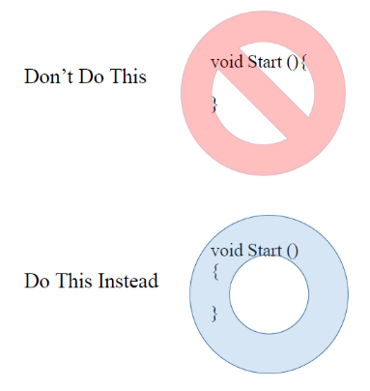**Coding Style**

**Avoid K&R Braces** (https://en.wikipedia.org/wiki/Indent_style#K.26R_style)

**Use Allman Braces** (https://en.wikipedia.org/wiki/Indent_style#Allman_style)

**Visual Studio**

Do not use Monodevelop whenever possible, Use Visual studio instead.

**Edit->Preferences->External Tools->External Script Editor**

**Scripts Folder**

All scripts should be placed one of the folders in the base script folder. If no folder is representative of the script, create a new folder, or place in Utility folder.

# Editor Overview

**Project Version - Unity 5.2**

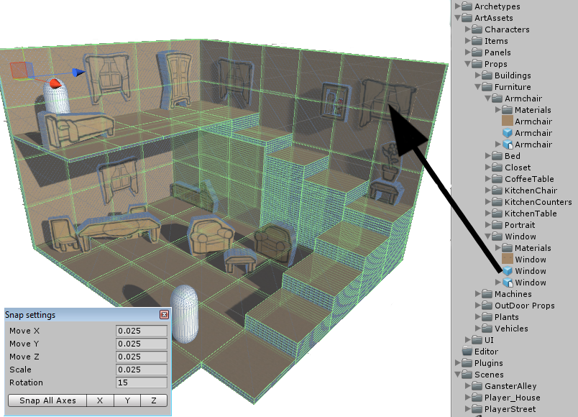

**Editor Basics**

**Playmode Tint**

**Edit->Preferences->Color**

**Snap Settings**

**Edit->Snap Settings**

**Snap Settings: 0.025**

**Level Creation Overview**

Each Level should have a Level Settings Archetype to function properly.

# Special Systems

**Action System**

using ActionSystem;

Declare an action sequence or group

Update sequence or group in Update function.

Functions-

Action.Call

Action.Property

Action.Delay

**Event System**

EventSystem.GlobalHandler

Events.cs – List of all Registered events

**Interactable System**

Add interactable component to object.

Optionally you can add the interact collider and level settings in the inspector.

**Conversation System**

Conversation Script

# Art Pipeline

**Art Tools**

Maya

Photoshop

**Art Process**

Refer to “HowToMakeMayaModels.txt” in Art Assets for detailed guide.

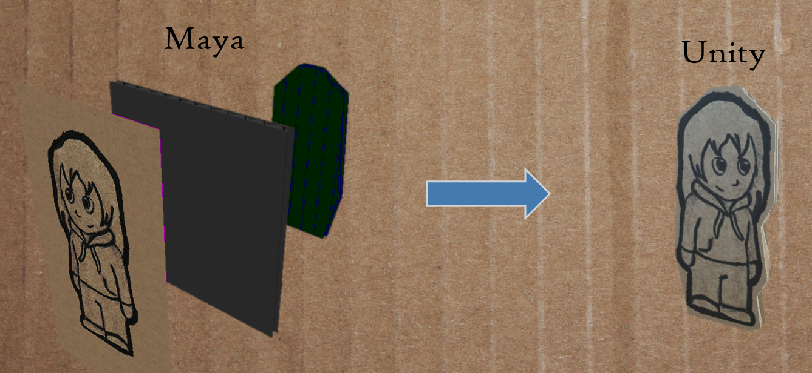

# Source Control Overview

**Overview**

Repository – GIT

Repository Link – https://github.com/ThePaperMill/PaperCut

**Using Git**

**Committing Changes**

If you have changes, type in a message THEN press the ‘Commit’ button. If the commit fails, use Tortoise Git, if that fails, use the command line. (git commit –m “Insert message here”)

To use TortoiseGIT to commit, right click on the repository folder and click “Git commit -> master”, in the bottom of the window you should check all the files you wish to commit. Next, enter your message and click ‘OK’.

**Syncing**

Press Sync. This will pull the latest changes and push your unpushed commits.

When the blue bar is full, the sync is complete.

**Sync Conflicts**

If you try to sync, but fail. That likely means that there are conflicts. In the GitHub tool, the conflicts will be marked in yellow and will be automatically **unchecked**. If you want to discard your changes, right click on the conflicting file and say “discard changes”. This sometimes takes a bit.

In TortoiseGIT, the conflicts will be marked in **red**. If you right-click on the conflict, you will have to option to ‘Resolve using mine’, ‘Resolve using theirs’, or ‘Resolve using merge tool.